**Project Design Phase**

**Solution Architecture**

|  |  |
| --- | --- |
| Date | 29 June 2025 |
| Team ID | LTVIP2025TMID54764 |
| Project Name | HouseHunt: Finding Your Perfect Rental Home |
| Maximum Marks |  |

**Solution Architecture:**

To provide a user-friendly, secure, and scalable **house rental platform** that bridges the gap between tenants and property owners or agents.

* Effortless Property Search and Booking
* End-to-End Rental Management
* Scalable User Authentication and Authorization
* Secure and Trackable Rent Payment Transactions
* Reliable Real-Time Chat and Notifications

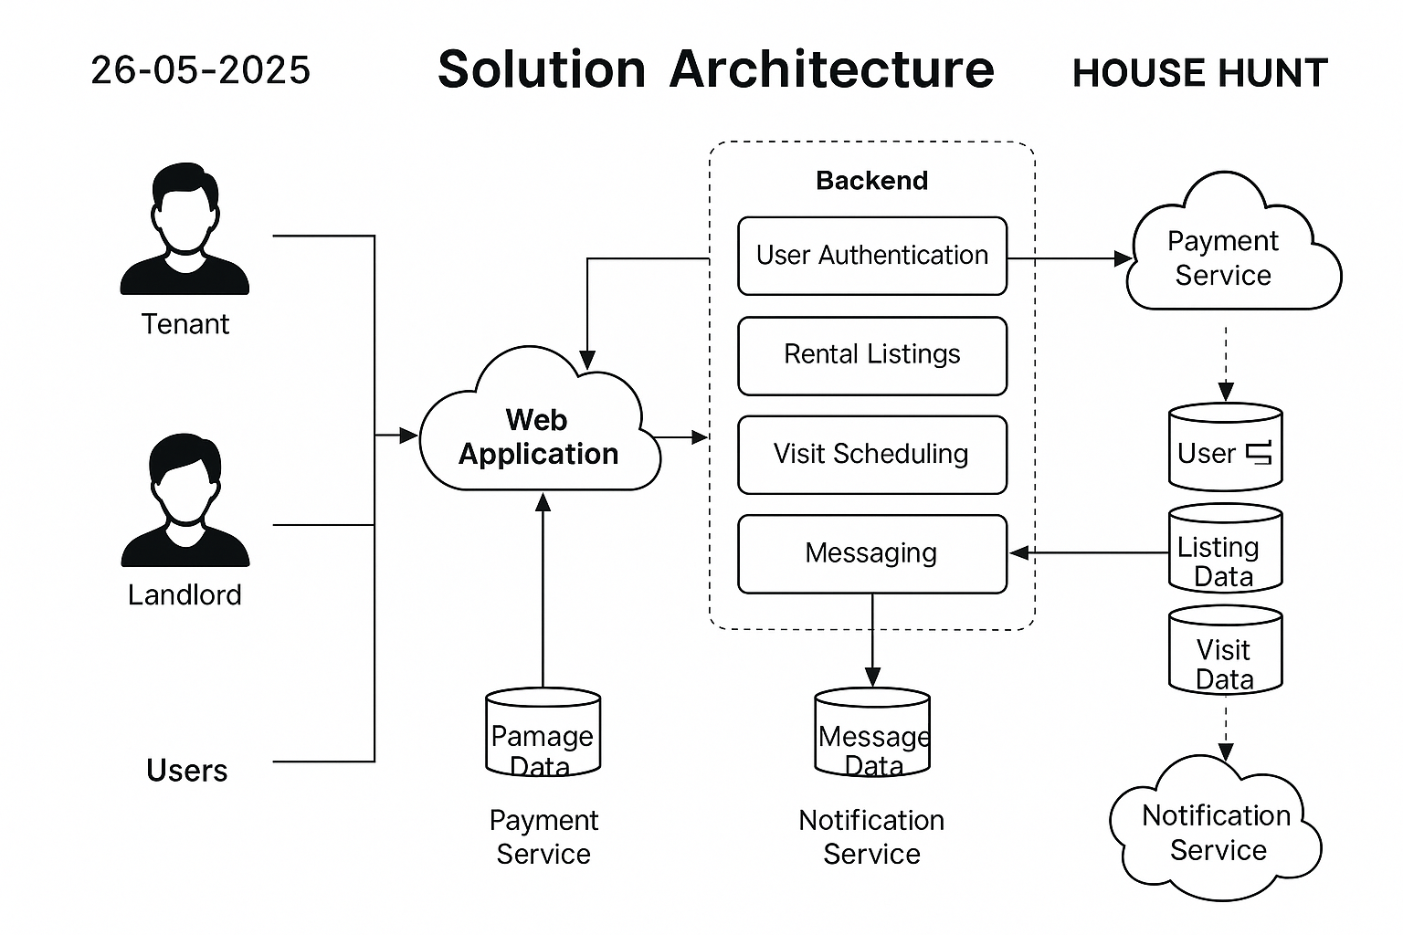**Example - Solution Architecture Diagram:**